Multiple-choice section

|  |  |  |  |  |  |  |  |  |
| --- | --- | --- | --- | --- | --- | --- | --- | --- |
| Question | 1 | 2 | 3 | 4 | 5 | 6 | 7 | 8 |
| Answer | C | A | A | B | D | D | B | C |

Question 1 [8.1]

C

intersects two or more other lines

Question 2 [8.2]

A

The shape is a parallelogram.

Therefore, the opposite angles are equal. So if one angle is 110°, the opposite angle is 110°.

Angles in a parallelogram add up to 360°.

360° – (110° + 110°) = 140°

140° ÷ 2 = 70° (opposite angles in a parallelogram are equal)

Question 3 [8.4]

A

ASA (Angle Side Angle)

Question 4 [8.2]

B

48° + 67° + *x* = 180°

115° + *x* = 180°

*x* = 65°

Question 5 [8.3]

D

Since *ABCD* is congruent to *PQRS*.

*AD* = *PQ* = 10

*BC* = *RS* = 12

*DC* = *PS*

*AB* = *QR*

Question 6 [8.3]

D

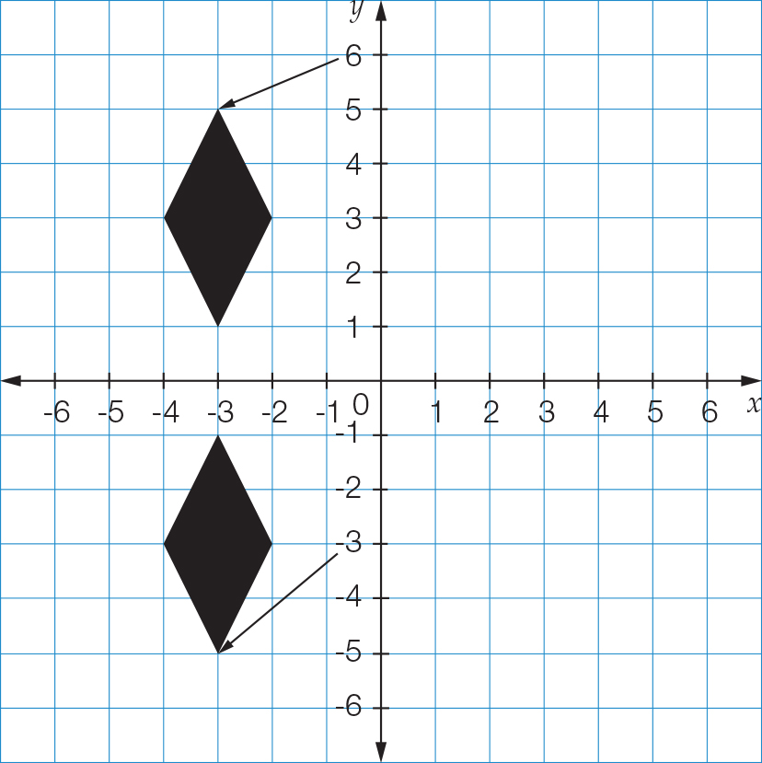

Question 7 [8.5]

B

The two angles between sides of different lengths are equal.

Another angle must be 88°.

Question 8 [8.5]

C

Multiple-choice total marks: 8

Short answer section

Question 9 2 marks [8.1]

(a) 22° + 158° = 180° (supplementary angles add to 180°)

(b) 74° + 16 ° = 90° (complementary angles add to 90°)

Question 10 3 marks [8.1]

∠*COB* = 180° ̶ 155° = 25° (angles on a straight line add to 180°)

∠*BOD* – ∠*COB* = ∠*DOC*

152° – 25° = 127°

∠*DOC* = 127°

Question 11 2 marks [8.1]

360° – 278° = *x*

*x* = 82° (angles in a revolution)

Question 12 4 marks [8.1]

*m* = 145° (angle is vertically opposite 145°)

*n* = 145° (corresponding angles with *m* or alternate to 145°)

Question 13 2 marks [8.2, 8.3]

(a) A *rectangle* has both pairs of opposite sides equal in length.

(b) Another name for a flip is a *rotation*.

Question 14 6 marks [8.2]

*a* + 72° = 180°

*a* = 108° (co-interior angles on parallel lines add to 180°)

72° = 3*b* – 3°

3*b* = 75°

*b* = 25° (opposite angles in a parallelogram are equal)

108° = 2*c* + 4°

104° = 2*c*

*c* = 52° (opposite angles in a parallelogram are equal)

Question 15 2 marks [8.4]

Triangles B and C are congruent. Triangle A has the measurement 10 on the side opposite  
the right angle, therefore it is not congruent to triangles B and C.

There is a side, an angle and another side that are the same in triangle B and C.

Side = Side (10 given)

Angle = Angle (Right angle given)

Side = Side (one dash)

Therefore, the triangles B and C are congruent, using SAS as the congruence test.

Question 16 2 marks [8.2]

Decagon has 10 sides, *n* = 10

(10 – 2) × 180°

= 8 × 180°

= 1440°

Question 17 6 marks [8.3]

(a)–(d) *A′′′* (-6, -4), *B′′′* (-4, -2), *C′′′* (0, -3), *D′′′* (-3, -5)

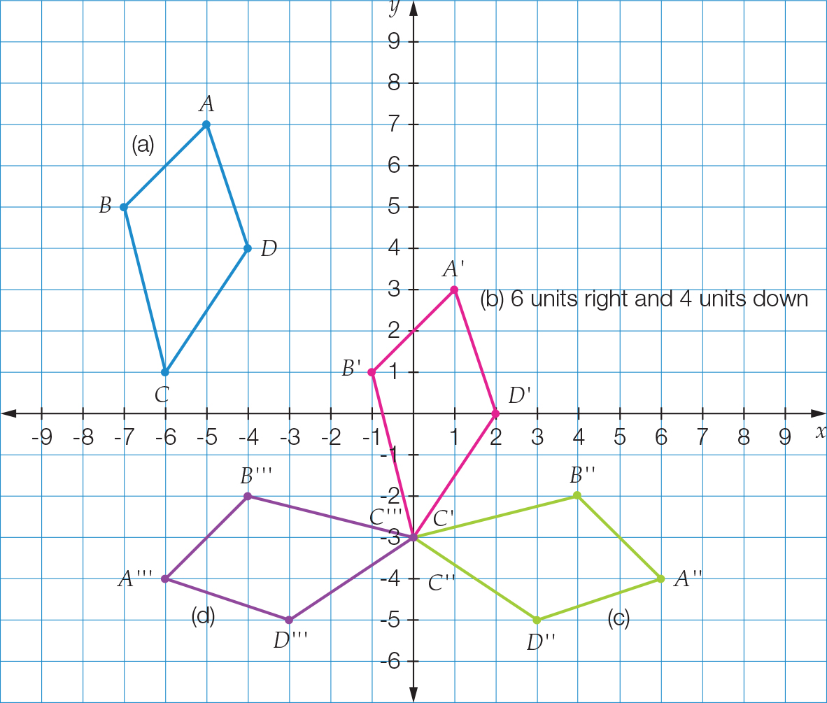

Question 18 4 marks [8.5]

(a) In a trapezium the diagonals are not congruent, as it does not have any special diagonal properties, so the statement is false.

(b) Both pairs of opposite angles in a rhombus are equal, so they are congruent, therefore the statement is true.

(c) In a rectangle, both pairs of opposite sides are equal, so they are congruent, therefore the statement is true.

(d) The sides are not parallel to one another in a kite, therefore the statement is false.

Question 19 3 marks [8.4]

(a) *AB* = *DE*; *AC* = *DF*; *BC* = *EF*∆*ABC* ≡ ∆*DEF*  Side Side Side (SSS)

(b) ∠*EFD =*∠*EDF* (base angles in isosceles triangle)∠*EDF* = 82°

Question 20 2 marks [8.5]

Left and right triangles are congruent and are isosceles triangles.

Top and bottom triangles are congruent and are isosceles triangles.

*x* = 63° (base angles in isosceles triangle)

Short answer total marks: 38

Extended answer section

Question 21 4 marks [8.2]

*x* – 8° + *x* + 12° + *x* + 2° = 180°

3*x* + 6° = 180°

3*x* = 174°

*x* = 58°

*x* + 12° = 58° + 12° = 70°

*x* – 8° = 58° – 8° = 50°

*x* + 2° = 58° + 2° = 60°

Question 22 5 marks [8.2]

(a) *a* = 79° (corresponding angles on parallel lines)  
*b* = 68° (alternate angles on parallel lines)  
*c* = 180° – 79°  
*c* = 114° (supplementary angles add to 180°)

(b) ∠*BEI* (corresponding angles on parallel lines)

(c) 79° + 68° + 101° + ∠*AHI* = 360°  
248° + ∠*AHI* = 360°  
∠*AHI* = 112°

Extended answer total marks: 9

TOTAL test marks: 55